
FOSSELAT ACADEMY
Placement Test — Version 4
Curriculum Alignment & Implementation Report
One Student Division · 6 programs · 26 level banks · 981 curriculum-aligned questions
Adaptive upgrade/downgrade placement · 60% mastery per level · 47,483 engine assertions · 383 real-browser checks
ملخّص تنفيذي (بالعربية)
أُعيد بناء اختبار تحديد المستوى داخل تطبيق React ليطابق الإطار الجديد للمناهج: قسم واحد للطلاب، وثلاثة مسارات، وستة برامج (القراءة والتجويد 4 مستويات · الحفظ 4 · الإجازة 2 · التأسيس 4 · ما بعد التأسيس 6 · الدراسات الإسلامية الشامل 6).
أُلغي تقسيم الأطفال/الكبار نهائيًا: سؤال السنّ أصبح اختياريًا ومعلوماتيًا فقط ولا يؤثّر على أي شيء في الاختبار.
نفس فكرة الترقية والتخفيض: سؤال تقرير ذاتي يحدّد نقطة البداية فقط، ثم 10 أسئلة لكل مستوى؛ 60% فأكثر = نجاح وصعود، وأقل = نزول للمستوى الأدنى غير المُثبت؛ والنتيجة النهائية هي أول مستوى لم يُتقنه الطالب.
بنك الأسئلة أعيد تصنيفه بالكامل على كفايات الإطار الجديد: 981 سؤالًا في 26 بنكًا، وحُذف 128 سؤالًا خرجت موضوعاتها عن المنهج الجديد، وأُلّف 75 سؤالًا جديدًا لسدّ الفجوات، وبرنامج الحفظ دخوله متاح للجميع بلا أي شرط قراءة.
النص العربي في الواجهة كبير وواضح كما كان أو أكبر، ومُختبَر على شاشة 390 بكسل بدون تمرير أفقي.
كل الفحوصات نجحت: 47,483 تحقّقًا في المحاكاة + 383 فحصًا في متصفح حقيقي، وأمثلة المواصفة الأربعة تحقّقت حرفيًا.
A. Updated Placement Test Architecture
The Placement Test is now a direct assessment instrument for the new Curriculum Framework. It keeps the existing React application, dark visual theme, screen components, deep links and local-storage resume behaviour — and replaces the internal academic machinery (division routing, question blocks, banded percentage placement) with the adaptive level engine.
Student flow
• Welcome → Track → Program. One Student Division: the Kids/Adults screen is removed. Track and program selection are unchanged UI patterns.
• Test intro. Shows questions-per-level, the 60% rule and an OPTIONAL age field marked “saved for our records only; it never affects your placement”. The value is stored on the result object and used nowhere in the logic.
• Self-report (initial routing). One question per program (“Where is your Qur'an reading today?” …). Its only effect: the test begins one level below the claimed level (prerequisiteLookback = 1). It earns no marks.
• Level loop. 10 questions from the current level's bank — never mixed with another level. ≥60% (6/10) = pass → move up; <60% = fail → move down to the previous unproven level; the loop ends when the starting level is pinned.
• Results. Recommended starting level = first unmastered level; per-level score rows (pass/fail per level, never one global percentage); strengths and areas to build by skill; duration and pace cards.
Files
File | Role | Status
PlacementTest.jsx | Screens and flow control (welcome, track, program, intro, self-report, stage, question, results) | Rewritten around the level engine; UI shell, theme, resume and deep links preserved
placementEngine.js | NEW — pure logic module: selection, grading, up/down routing, placement, persistence snapshots | Shared by the app and by the automated test harness
PlacementTest.css | Existing dark theme + new styles: large RTL Arabic options, stage screen, per-level result rows, age field | Extended only; Arabic stimulus size increased
questions.json | The v4 question bank + level structure + self-reports + config | Rebuilt for the new curriculum (schema v4.0)
PlacementTests.css / package.json | Listing-page styles; dependencies | Untouched — no new dependencies added
Configuration (one place)
Key | Value | Meaning
masteryThreshold | 0.60 | Pass mark per level: 60% passes exactly, 59% fails
questionsPerLevel | 10 | Served per level for every student (one division)
difficultyMix | 30 / 45 / 25 | Easy / medium / hard quota in every served set
prerequisiteLookback | 1 | Test starts one level below the self-reported claim
placementMode | firstUnmastered | Recommendation = highest mastered + 1 (capped at top)
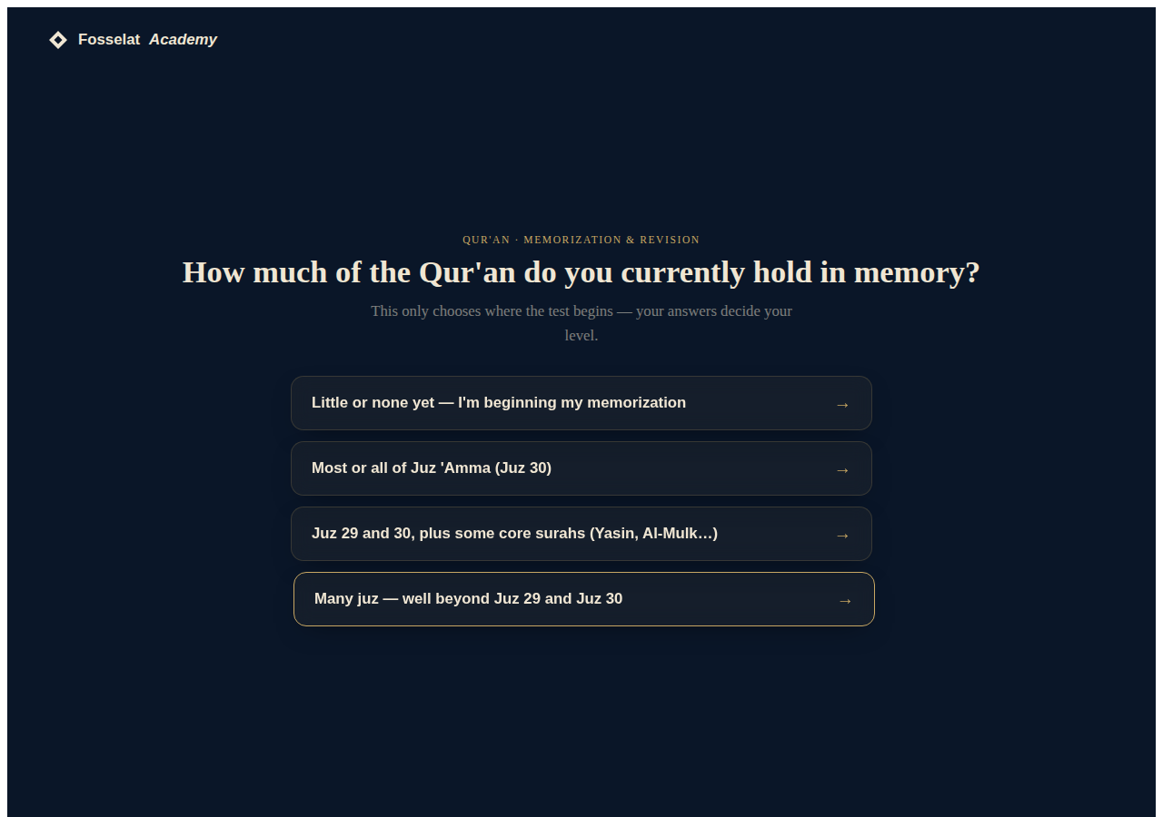
Self-report: sets the starting point only — “your answers decide your level”
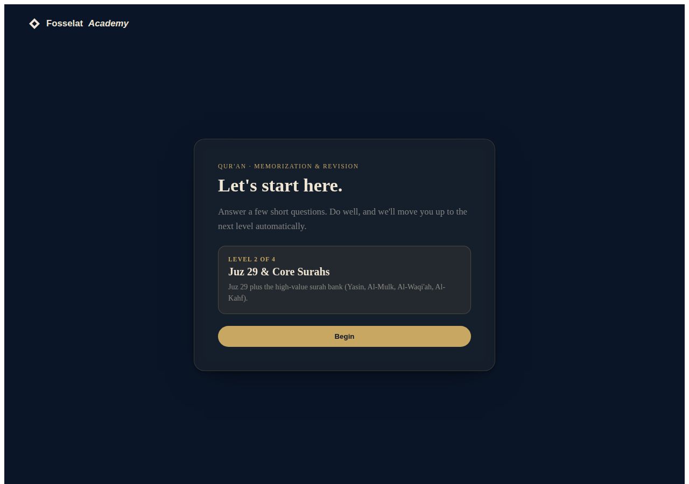
Between-level stage screen (upgrade / downgrade messages)
B. Updated Question Banks
Every item in the previous banks was re-audited against the new framework, reclassified to the level whose competencies it measures, merged across the former Kids/Adults division, or removed when its topic left the curriculum. New items were authored wherever a level lacked coverage.
Headline: From 1478 audience-split items (v3) to 981 one-division items (v4) in 26 level banks. 128 items dropped as out-of-curriculum, 75 new items authored, and every bank holds at least 16 items against the 10 served.
What changed per program
Program | Rebuild summary
Reading & Tajweed (4) | Items reclassified to the new integrated progression: L1 letters+short vowels · L2 elongation+tanwin · L3 sukun/shaddah + nun & mim rule sets + stopping · L4 articulation, madd hierarchy, waqf & ibtida. Advanced articulation items shared from the Ijazah bank into L4; 12 new items (easy elongation band, waqf signs, ra/lam rules, sakt, recitation paces).
Memorization & Revision (4) | The existing passage-recognition assessment is kept as-is (concept unchanged). Every passage item was located in the Qur'anic corpus and assigned by juz: Juz 30 → L1; Juz 29 + Yasin/Al-Mulk/Al-Waqi'ah/Al-Kahf → L2; juz 15–28 → L3; the long early surahs → L4. No reading questions and no reading prerequisite anywhere: entry is open, placement is by memorization status.
Ijazah Preparation (2) | Unchanged program: the two-level structure and its advanced banks kept, kids/adults duplicates merged (73 items).
Arabic Foundation (4) | Remapped to the new literacy progression: L1 letters+short vowels · L2 long vowels+closed syllables+moon article · L3 tanwin+shaddah = decoding autonomy · L4 fluency + spelling/orthography. 11 new items (long-vowel contrast, moon-letter article, hamzah seats, alif maqsurah, dictation-style spelling, passage fluency). Conversational items moved to Post-Foundation where they belong.
Arabic Post-Foundation (6) | Restructured from 4 levels to the framework's 6. Existing items reclassified by function and grammar load; 34 new items authored for the new bands: transactions/travel/health (PF2), case & mood essentials + news comprehension (PF4), conditionals/passive/participles/morphology (PF5), advanced syntax + register + proverbs (PF6).
Islamic Studies — Comprehensive (6) | The seven former programs (comprehensive + aqeedah, fiqh, seerah, hadith, tafsir, manners) folded into ONE six-level spiral matching the framework: each item classified into L1–L6 by its competency (e.g. wudu → L3, tayammum & conditions of faith → L4, forms of worship & salah structure → L5, shirk types & janazah → L6). 121 items on sciences outside the new syllabus (isnad/grading, tafsir methodology, usul, detailed zakah rulings…) were dropped; 18 new items authored (first foundations, adhan, salah terms, vows/sacrifice, janazah, post-prayer adhkar, witr, amulets/riya).
Bank sizes after the rebuild (pool vs 10 served)
Program / Level | Level name | Pool | e/m/h | Skills
Reading & Tajweed — L1 | Letter & Sound Foundations | 36 | 12/20/4 | 5
Reading & Tajweed — L2 | Elongation & Word Fluency | 25 | 4/8/13 | 3
Reading & Tajweed — L3 | Connected Reading & Core Rules | 73 | 3/53/17 | 9
Reading & Tajweed — L4 | Fluent Recitation & Applied Mastery | 29 | 2/11/16 | 6
Memorization & Revision — L1 | Juz Amma (Juz 30) | 51 | 1/36/14 | 3
Memorization & Revision — L2 | Juz 29 & Core Surahs | 56 | 0/35/21 | 3
Memorization & Revision — L3 | Half-Qur'an Memorization | 41 | 0/18/23 | 2
Memorization & Revision — L4 | Complete Hifz (Khatm) | 24 | 0/6/18 | 2
Ijazah Preparation — L1 | Ijazah Foundation (Pre-Sanad) | 42 | 0/25/17 | 5
Ijazah Preparation — L2 | Ijazah Certification (Sanad) | 31 | 2/13/16 | 7
Arabic Foundation — L1 | Letters & Short Vowels | 36 | 15/18/3 | 7
Arabic Foundation — L2 | Long Vowels & Closed Syllables | 20 | 2/14/4 | 4
Arabic Foundation — L3 | Tanwin, Shaddah & Decoding Autonomy | 23 | 6/14/3 | 4
Arabic Foundation — L4 | Fluency, Orthography & Writing Foundations | 20 | 0/15/5 | 3
Arabic Post-Foundation — L1 | Survival Communication (PF1) | 23 | 5/16/2 | 3
Arabic Post-Foundation — L2 | Everyday Transactions (PF2) | 19 | 4/11/4 | 7
Arabic Post-Foundation — L3 | Social Communication & Foundational Grammar (PF3) | 25 | 4/19/2 | 4
Arabic Post-Foundation — L4 | Connected Discourse & Contemporary Topics (PF4) | 19 | 1/7/11 | 3
Arabic Post-Foundation — L5 | Extended Reading & Structural Depth (PF5) | 18 | 0/7/11 | 3
Arabic Post-Foundation — L6 | Academic Readiness & Composition (PF6) | 16 | 0/3/13 | 4
Comprehensive Islamic Studies — L1 | First Foundations of Faith & Daily Practice | 34 | 12/16/6 | 9
Comprehensive Islamic Studies — L2 | The Framework of the Deen | 98 | 30/43/25 | 27
Comprehensive Islamic Studies — L3 | Evidence & the Foundations of Worship | 56 | 17/27/12 | 17
Comprehensive Islamic Studies — L4 | Tawheed, Purification & the Conditions of Faith | 61 | 19/29/13 | 17
Comprehensive Islamic Studies — L5 | Forms of Worship & Establishing the Prayer | 61 | 18/29/14 | 18
Comprehensive Islamic Studies — L6 | Guarding Tawheed & Complete Devotional Practice | 44 | 5/24/15 | 16
Quality rules enforced on every item (build-time audit)
• Four distinct options, verified correct index, and a stored correctAnswer string.
• No answer leakage: the correct option may not be conspicuously longer or shorter than the distractors; Arabic-text option sets are length-balanced across each bank.
• No “all/none of the above”; the prompt may not contain its own answer; no duplicate items within a program.
• Correct answers deterministically rotated across all four positions (no position pattern).
• Metadata on every item: track, program, level, skill, topic (strand), competency, difficulty, type, points.
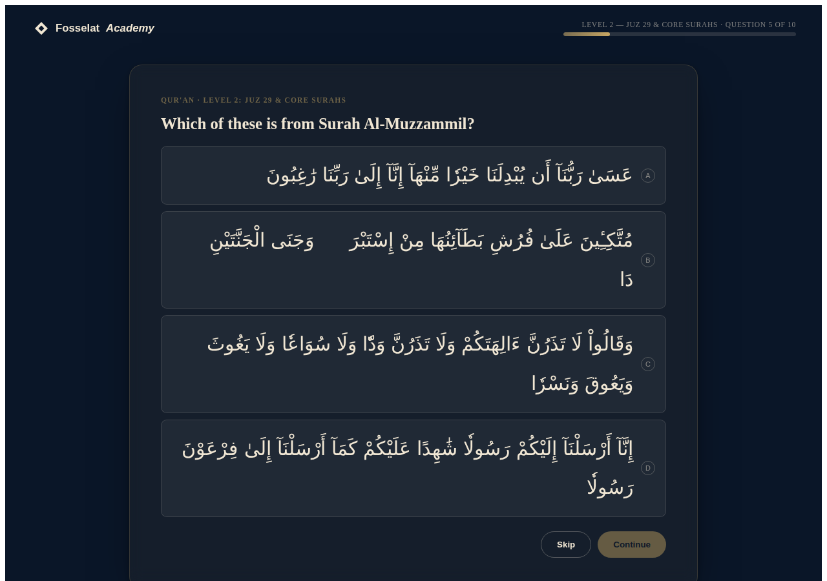
Memorization item: large RTL Qur'anic options — readability prioritized over compactness
C. Updated Placement Logic
The algorithm is the upgrading/downgrading concept of the previous placement system, applied to the new curriculum structure:
1. Initial routing: the self-report answer estimates a claim; the test starts one level below it (clamped to the program's range). This step only chooses the starting point.
2. Test the level: 10 questions from that level's bank (difficulty quota 30/45/25, skills rotated, options shuffled per student, easiest first).
3. Score the level independently: correct ÷ 10. No cross-level averaging exists anywhere in the system.
4. ≥ 60% = pass → move UP one level and test it. < 60% = fail → move DOWN to the previous level if it is not yet proven; otherwise stop.
5. Stop conditions: failing with the level below already proven; failing the lowest level; passing the highest level; or passing a level whose next level was already attempted.
6. Final starting level = the first level the student did not master (highest mastered + 1, capped at the top level). No previous mastery → Level 1.
Why not a single percentage
A global percentage hides which competencies exist. Here every decision is taken on one level's own evidence: question difficulty is balanced inside each set by quota, competency importance is expressed by which items each bank contains, prerequisite skills are protected by the downgrade path (a student can never be placed above a level they failed to demonstrate), and consistency is enforced by requiring a full 10-question pass at every level on the path. The 60% threshold itself is pedagogically pinned: with 10 questions it is exactly 6 correct, and a pure guesser's chance of passing any single level is 1.97%.
Specification examples — verified in code and in the browser
Example | Path | Result (verified)
1 | Start L1 → pass L1, pass L2, fail L3 | Starts at Level 3 ✓
2 | Start L3 → fail L3, fail L2, pass L1 | Starts at Level 2 ✓
3 | Start L2 → pass L2, pass L3, fail L4 | Starts at Level 4 ✓
4 | Start L3 → pass L3, pass L4 (top) | Starts at Level 4 ✓
Edge cases handled
• Claiming the top with no ability: descends level by level and lands at Level 1.
• Skipped questions count as unanswered (wrong) — the test still completes and places.
• Abandoned test: progress is saved locally; resuming restores the same questions, the same option order and the same earned answers; saves expire after 7 days.
• Program entry vs level placement: choosing a program is the student's decision; the test never re-routes them to another program. Memorization & Revision carries an explicit access note — no reading requirement of any kind.
• Age: collected optionally, stored on the result, provably absent from selection, scoring and placement (asserted in tests).
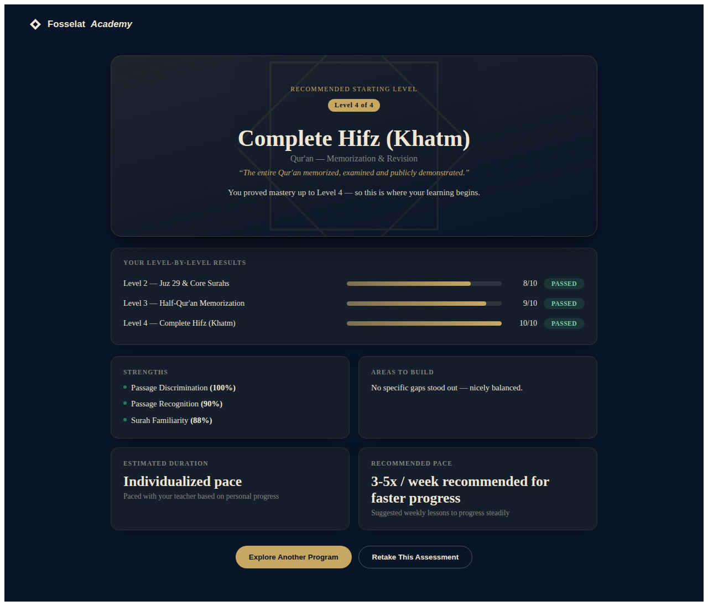
Results: per-level pass/fail rows, first-unmastered recommendation, skill profile
D. Updated Code
Removed (with the reason)
• Kids/Adults audience screen, audience filtering and per-audience level tables — the framework has one Student Division.
• Question “blocks” with pass/mid/fail routing and placement bands (score → level lookup) — replaced by per-level banks and the up/down engine.
• Self-rating scoreMap items and complete-the-verse items in Memorization — placement there is now measured by passage recognition only.
• timedRead (self-timed reading) and free-text shortAnswer types — non-objective inputs; every assessment item is now auto-scorable MCQ.
• The old localStorage snapshot format (v1) — superseded by the v2 snapshot; old keys are cleaned up automatically.
Preserved
• The entire visual identity, screens, cards, progress bar, resume banner and results layout patterns.
• React Router integration, the topbar brand button, and ?track=…&program=… deep links (an old ?audience parameter is simply ignored).
• localStorage-based save/resume with a 7-day expiry, storage-availability guards, and the same fetch('/questions.json') data loading.
• No new dependencies: package.json is untouched; the engine is dependency-free.
E. Testing Results
Engine simulation (Node, shares the exact app engine module)
Suite | Coverage | Outcome
Structure | 3 tracks, 6 programs, level counts 4/4/2/4/6/6, 26 banks ≥16 items, metadata on all 981 items, zero audience keys | PASS
Deterministic placement | 150 students: every program × every self-report claim × every ability level — exact expected placement, mastery flags, contiguous level paths | PASS
Threshold | 6/10 passes exactly; 5/10 fails; failing L1 places at L1 | PASS
Spec examples | The four upgrade/downgrade walk-throughs reproduce the specified outcomes | PASS
Self-report & age | Over-claimers with no ability always land at Level 1; identical sessions with different ages get identical questions | PASS
Guessing | 400 Monte-Carlo guessers: 4.0% ever prove any level (single-level pass chance 1.97%) | PASS
Resume | Mid-level snapshot → rehydrate → identical questions, options and final placement | PASS
Fuzz | 240 randomized students with skips and noisy ability across all programs — always terminates, always places in range | PASS
Bias | Correct-answer positions spread across A–D in every bank; no option-length giveaway | PASS
Total | 47,483 assertions | ALL PASS
Real browser (Playwright on the Vite app)
Suite | Coverage | Outcome
A — Program routing | All six programs: strong student climbs from Level 1 to the top; correct level rows rendered | PASS
B — Over-claimer | Claims PF6, answers everything wrong → descends to Level 1 | PASS
C — Borderline | Pass L1 then fail L2 → recommended start Level 2 | PASS
D — Resume | Refresh mid-level → resume banner → continues at question 5 of 10 | PASS
E — One division | No audience screen; age field optional and marked non-academic; Memorization self-report asks about memorization, not reading | PASS
F — Mobile 390px | No horizontal scroll; Arabic stimulus ≥20px computed size; screenshot captured | PASS
Console | Zero application console errors across all suites (383 checks total) | PASS
The linter used by the project (oxlint) reports no issues on the new files.
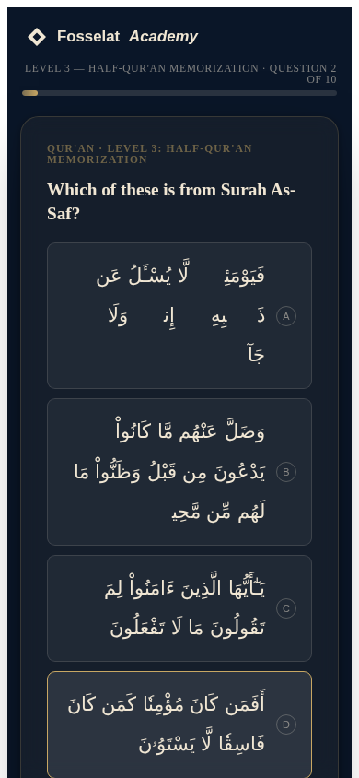
Mobile 390px — Arabic options remain large; no horizontal scrolling
F. Alignment Map — Curriculum → Competencies → Assessment → Placement
For every program: each curriculum level, the competencies it defines, what the placement test actually assesses (the skills present in that level's bank), and how the score is used. The placement rule is identical everywhere: 10 items from the level's own bank, pass at ≥60%, upgrade/downgrade, recommendation = first unmastered level.
Qur'an — Reading & Tajweed
Lvl | Curriculum level & focus | Competency measured | Assessed skills (bank)
L1 | Letter & Sound Foundations  All letters in every form, the three short vowels, blending into read words. | Identify and articulate every letter in all forms with the three short vowels | Letter Sounds, Letters in Words, Reading Words, Short Vowels, Similar Letters
L2 | Elongation & Word Fluency  Long vowels, the hamzah-triggered madd cases, tanwin, connected verse reading. | Control vowel length: madd cases and tanwin in connected reading | Long Vowels, Madd, Tanween
L3 | Connected Reading & Core Rules  Sukun, shaddah, the nun and mim rule sets, stopping behaviour, madd lazim. | Apply the notation-driven rules (sukun, shaddah, nun/mim sets, stopping) in real text | Madd, Madd Types, Meem Rules, Noon Rules, Qalqalah, Reading Accuracy, Stopping & Starting…
L4 | Fluent Recitation & Applied Mastery  Articulation points and attributes, the full madd hierarchy, waqf and ibtida, tarteel. | Recite with tarteel: articulation, full madd hierarchy, waqf & ibtida | Applied Rules, Madd Precision, Madd Types, Makharij & Sifaat, Stopping & Starting, Tajweed Rules
Qur'an — Memorization & Revision
Lvl | Curriculum level & focus | Competency measured | Assessed skills (bank)
L1 | Juz Amma (Juz 30)  All 37 surahs of Juz 30 memorized with correct tajweed. | Hold Juz 30 in accurate memory | Passage Discrimination, Passage Recognition, Surah Familiarity
L2 | Juz 29 & Core Surahs  Juz 29 plus the high-value surah bank (Yasin, Al-Mulk, Al-Waqi'ah, Al-Kahf). | Hold Juz 29 and the core surah bank in accurate memory | Passage Discrimination, Passage Recognition, Surah Familiarity
L3 | Half-Qur'an Memorization  Fifteen additional juz under a personal revision system. | Hold fifteen additional juz under active revision | Passage Recognition, Surah Familiarity
L4 | Complete Hifz (Khatm)  The entire Qur'an memorized, examined and publicly demonstrated. | Hold the complete Qur'an in examined memory | Passage Recognition, Surah Familiarity
Memorization & Revision: Access rule honoured: no reading ability is assessed or required anywhere in this program's placement; placement derives from demonstrated memorization only.
Qur'an — Ijazah Preparation
Lvl | Curriculum level & focus | Competency measured | Assessed skills (bank)
L1 | Ijazah Foundation (Pre-Sanad)  Error-free extended recitation with detailed command of tajweed theory. | Recite at examination grade and explain the governing ahkam | Applied Rules, Madd, Madd Precision, Makharij & Sifaat, Tajweed in Context
L2 | Ijazah Certification (Sanad)  The formal chained examination before a certified Sheikh/Sheikha. | Complete the formal chained certification | Advanced Application, Correction Skill, Ijazah Knowledge, Madd Types, Meem Rules, Stopping & Starting, Tajweed Rules
Arabic Language — Arabic Foundation
Lvl | Curriculum level & focus | Competency measured | Assessed skills (bank)
L1 | Letters & Short Vowels  The alphabet in all forms, the three short vowels, blending, first sentences. | Recognize and sound every letter; blend short-vowel words | Alphabet Order, Letter Names, Letter Shapes, Letter Sounds, Letters in Words, Reading Syllables, Short Vowels
L2 | Long Vowels & Closed Syllables  Vowel length, sukun, the definite article, first connected passages. | Decode long vowels and closed syllables; read connected passages | Long Vowels, Reading Syllables, Shaddah & Sukoon, Word Reading
L3 | Tanwin, Shaddah & Decoding Autonomy  The complete diacritic system; independent reading of unseen vowelled text. | Decode the complete diacritic system independently | Shaddah & Sukoon, Tanween, Vocabulary, Word Groups
L4 | Fluency, Orthography & Writing Foundations  Fluent oral reading, hamzah spelling rules, both orthographies, dictation. | Read fluently and apply the spelling system in both orthographies | Sentences, Spelling & Orthography, Words in Context
Arabic Language — Arabic Post-Foundation
Lvl | Curriculum level & focus | Competency measured | Assessed skills (bank)
L1 | Survival Communication (PF1)  Greetings, self, family, home and daily life in first correct exchanges. | Communicate about self and daily life in short correct exchanges | Conversation, Everyday Arabic, Vocabulary
L2 | Everyday Transactions (PF2)  Shopping, weather, travel, health and holidays; simple past-tense narration. | Handle everyday transactions and narrate simple past events | Conversation, Health, Numbers, Transactions, Travel, Verbs, Vocabulary
L3 | Social Communication & Foundational Grammar (PF3)  Society-level topics, the first explicit grammar system, cohesive paragraphs. | Discuss social topics using the foundational grammar system | Grammar, Nouns & Adjectives, Reading Comprehension, Sentence Formation
L4 | Connected Discourse & Contemporary Topics (PF4)  Argument and opinion, the case and mood essentials, media-style comprehension. | Argue and justify with case/mood control and media comprehension | Expression, Grammar, Reading Comprehension
L5 | Extended Reading & Structural Depth (PF5)  Long texts, morphology, conditionals and passive, summary skills. | Read extended texts with morphological and structural depth | Advanced Grammar, Advanced Reading, Morphology
L6 | Academic Readiness & Composition (PF6)  Advanced syntax, formal register, extended composition and debate. | Operate at pre-academic level: advanced syntax, register, composition | Advanced Grammar, Advanced Reading, Expression, Reading Comprehension
Islamic Studies — Comprehensive Islamic Studies
Lvl | Curriculum level & focus | Competency measured | Assessed skills (bank)
L1 | First Foundations of Faith & Daily Practice  Who Allah is and who His Messenger ﷺ is; first surahs, daily supplications, sunnah routines. | State the first certainties of faith and live the daily sunnah practices | Belief, Central Message, Eating & Drinking, Famous Hadith, Kindness & Care, Manners & Du'a, Qur'an Knowledge…
L2 | The Framework of the Deen  Islam, Iman and Ihsan; the five pillars and six articles; the etiquette systems. | Command the framework of the deen: pillars, articles and etiquette | Angels & Books, Angels and Books, Belief, Belief in Allah, Famous Hadith, Fasting, Foundations of Belief…
L3 | Evidence & the Foundations of Worship  The three principles, complete wudu, the connected seerah arc, the creed lists. | Evidence the three principles, perform wudu, narrate the seerah arc | Angels & Books, Angels and Books, Battles, Dates & Sequence, Dates & Timeline, Famous Hadith, Farewell Sermon…
L4 | Tawheed, Purification & the Conditions of Faith  Tawheed and taghut, the conditions of the shahadah, tayammum, heritage literacy. | Explain tawheed with its conditions and complete purification | Asbab al-Nuzul, Categories of Tawheed, Character Terms, Collections & Scholars, Famous Hadith, Hadith Collections, Hadith Compilers…
L5 | Forms of Worship & Establishing the Prayer  Every form of worship owed to Allah alone; the adhan and the structure of salah. | Attribute all worship to Allah alone and establish the prayer | Early Life, Forms of Worship, Hadith Basics, Key Events, Key People, Lessons & Significance, Migration…
L6 | Guarding Tawheed & Complete Devotional Practice  Major and minor shirk refuted; the prayer perfected with janazah and daily adhkar. | Refute shirk and perform the complete devotional system | Applied Aqeedah, Applying Character, Companions, Guarding Tawheed, Hadith Basics, Humility & Conduct, Key Events…
How to update the banks later
1. questions.json is the single source of truth the app loads at runtime. Each question carries its program, level, skill, topic, competency and difficulty.
2. To add or edit items, use the delivered dev tools: fill_items.py (authored items) and build4.py (assembler). Run python3 build4.py — it re-audits every rule above and refuses to write if anything fails.
3. Config lives in one place (meta.config): change the threshold, questions per level or placement mode there and the app follows.
4. Re-run node sim4.mjs (a few seconds) after any data change; run node ui_test.mjs against a dev server for a full browser regression.

